Note: This is the article that was submitted to the Community Focus.

Martinez Historic Home Tour Set for Oct. 8th
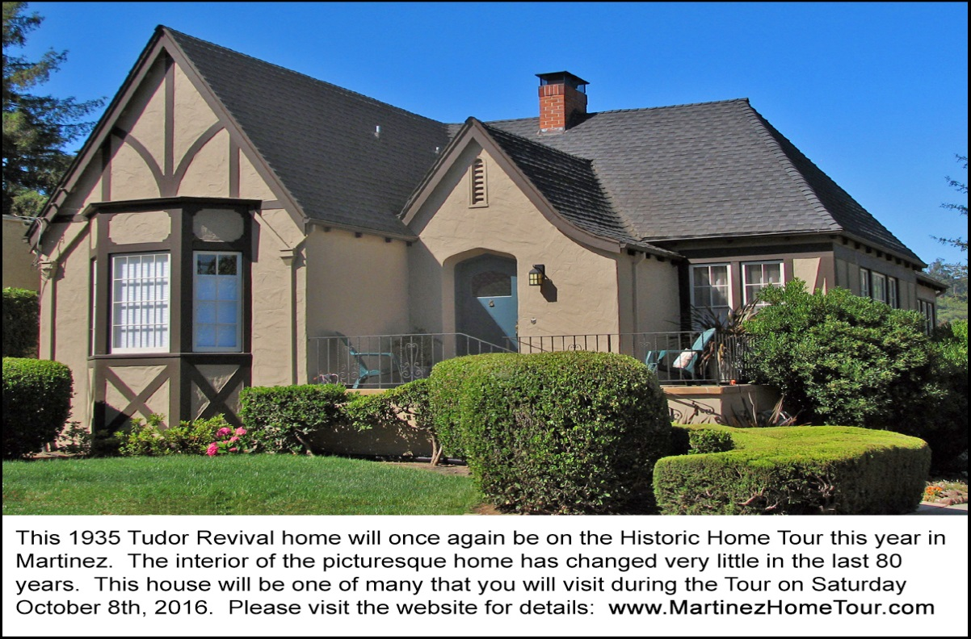
This 1935 Tudor Revival home will be one of seven houses on the 2016 Historic Home Tour in Martinez. The interior of this home is charming and has changed very little in the last 80 years.

MARTINEZ. The Historic Home Tour in Martinez is returning for the 10th consecutive year. This event, organized by the Martinez Historical Society, will enable you to stroll through 7 vintage homes that will be opened up to the public for one day only on Saturday, October 8th from 10am to 4pm.
The Tour will start at the Shell Clubhouse, a 1937 Arts & Crafts building on Pacheco Boulevard in Martinez. Complementary coffee will be served. There will be special exhibits set up in the Clubhouse for the day. Since this is an election year, there will be an impressive display of vintage political memorabilia. A complementary exhibit includes 20th Century press cameras and other camera models used by past presidents, first ladies and other politicians. More exhibits can be seen in the adjacent Shell Museum – with its own displays relating to the Martinez Refinery which was constructed in 1915.
For those who don’t want to drive their own cars, buses will depart from the Clubhouse every 10 minutes to shuttle tour goers onward to the homes that will be on the tour. The home styles are mainly American Craftsman and the romantic Tudor Revival style – popular in the 1920s and 1930s. There will be docents in each home to welcome visitors. There will be tour guides on the buses.
Marlene Haws, who helped select the homes for this year’s tour, reports that there is a special treat for tour goers this year: a visit to a wonderful garden where wildlife are rescued and rehabilitated. The animals in the garden are curious about humans instead of afraid.
Also on the Tour will be the Martinez Junior High School. Built in the Spanish Revival style, the 1931 building won a state-wide architectural award. Tour goers will see several of the original interior features which were left intact during the 1968 seismic retrofit and the 1999 renovation.
The Martinez Museum is also on the Tour route. “The Museum has been closed for a year while the 1890 Victorian structure was renovated,” reports John Curtis, Martinez Historical Society President “but the Tour will allow visitors to see the interior of the building and the new displays before it officially reopens to the general public a week later.”
“Each year’s Tour is different, “said Carolyn Duncan, Chair of the Home Tour Committee, “And we’re confident that this year’s Tour – with its highly personalized homes, antique automobiles, the wildlife sanctuary, the museums and local musicians -- will provide tour goers with a great visitor experience.”
Home Tour tickets are $25 in advance and $30 at the door. Tickets can be purchased by credit card at www.martinezhometour.com or www.eventbrite.com and with cash or check at the following Martinez stores: Char’s Flowers (635 Main Street), Peirano Jewelers (510 Center Avenue),), The UPS Store (Lucky Shopping Center) and I’ve Been Framed (411 Ferry Street).
The following sponsors make this tour possible:
Shell Martinez Refinery, Cole Real Estate, West Berkeley Design Loop, Shell Chemical Company, Republic Services, Shell Western States Federal Credit Union, Hagin’s Automotive, Bisio/Dunivan, Les Schwab Tire Center of Martinez, Ecomulch, Community Focus, City of Martinez, Leading Edge Pest Management, Schroder Insurance, Connolly & Taylor Chapel and Michael Briones of J. Rockcliff Realtors.

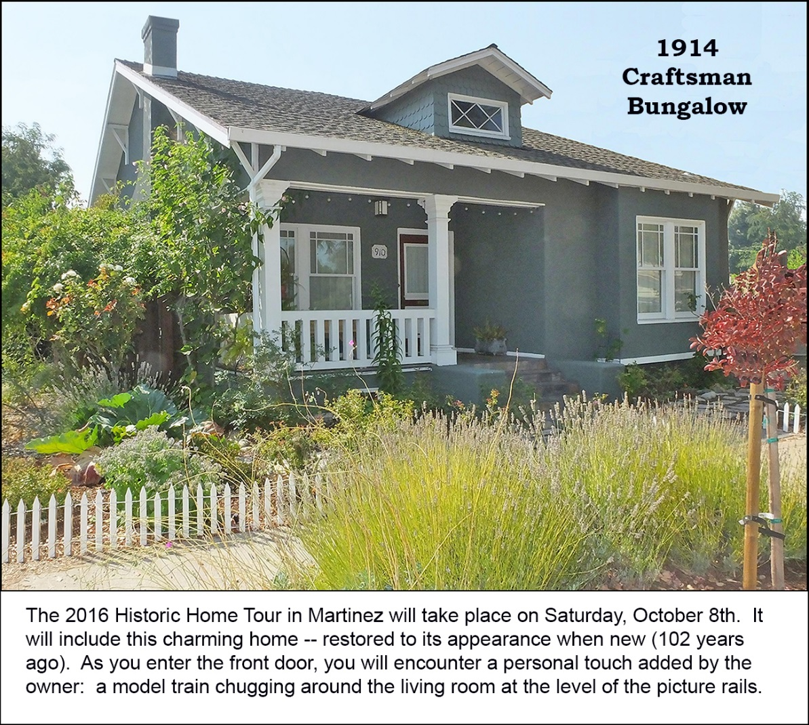
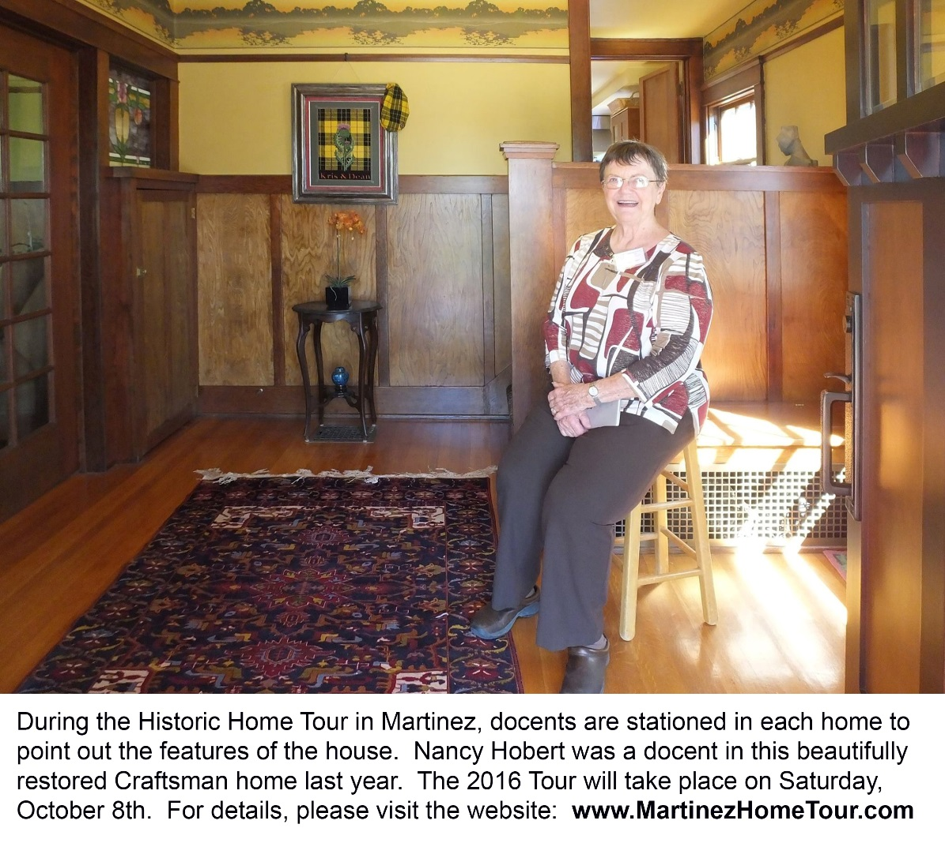
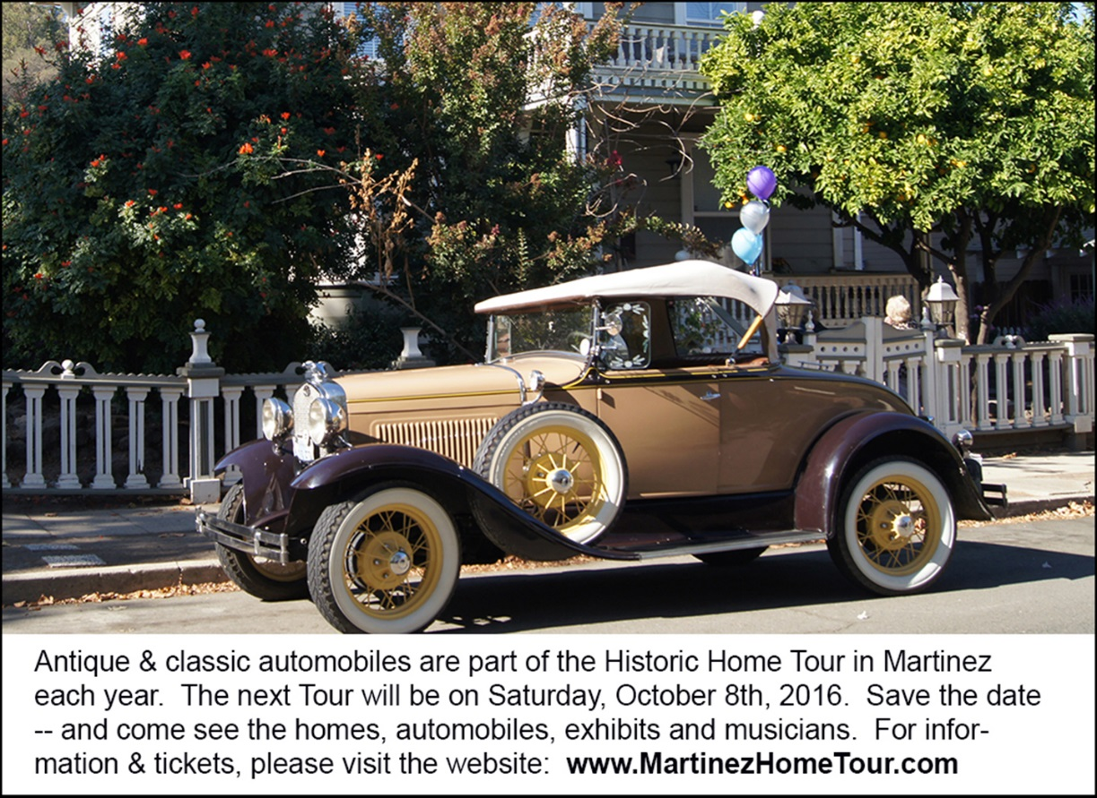

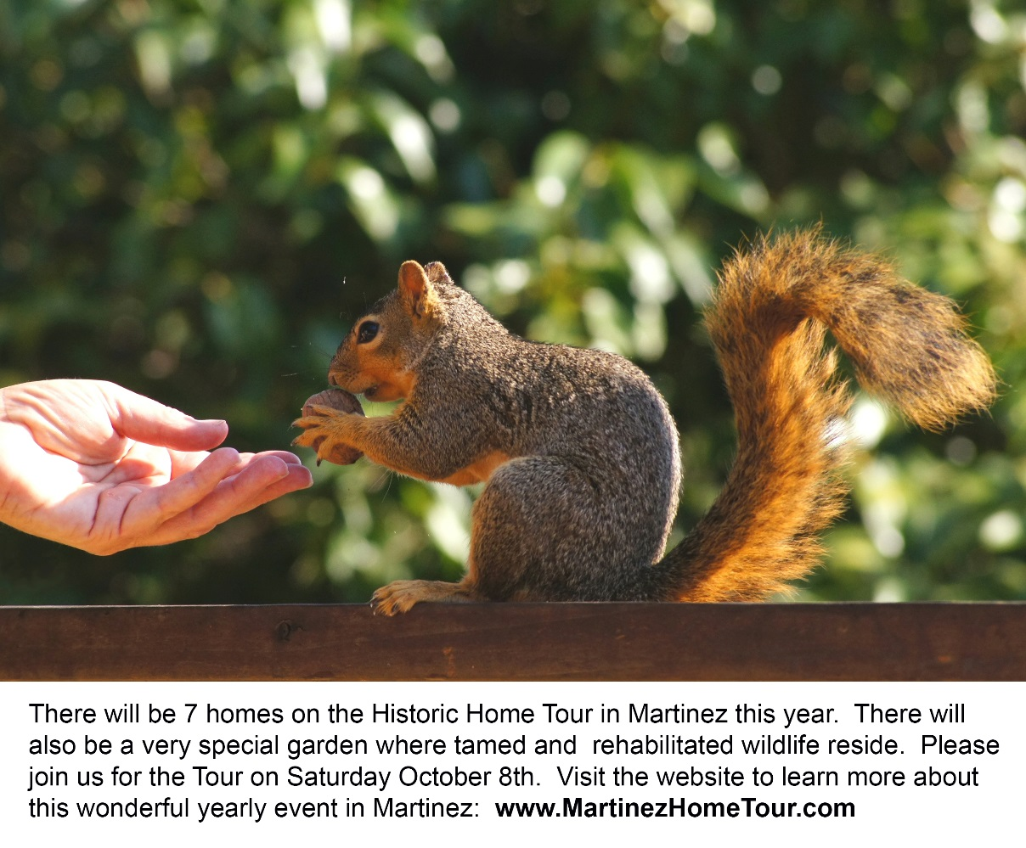
Note to editor:
- To see more Home Tour photos, please click here: press materials
- For more information, please contact the Home Tour Committee Chair, Carolyn Duncan, at (925) 864-8457.
- You may also contact John Curtis at CurtisJD@ix.netcom.com.

